Assignment 10

31418

Farkhanda Dalal

**AGGREGATION PIPELINE:**

1. Get total number of products and average price of all products:

db.Product.aggregate([

{

$group: {

_id: null,

totalProducts: { $sum: 1 }, // Count total products

avgPrice: { $avg: "$Price" } // Calculate average price

}

},

{

$project: {

_id: 0, // Exclude _id from result

totalProducts: 1,

avgPrice: 1

}

}

])

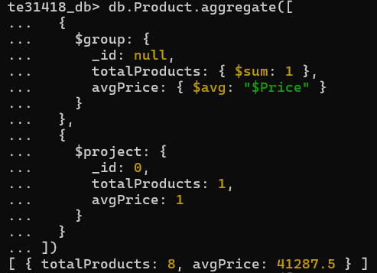

1. Find total value of inventory (sum of prices) grouped by Brand:

db.Product.aggregate([

{

$group: {

_id: "$Brand", // Group by brand

totalValue: {$sum: "$Price"} // Sum the prices for each brand

}

},

{

$sort: { totalValue: -1 } // Sort by total value in descending order

}

])

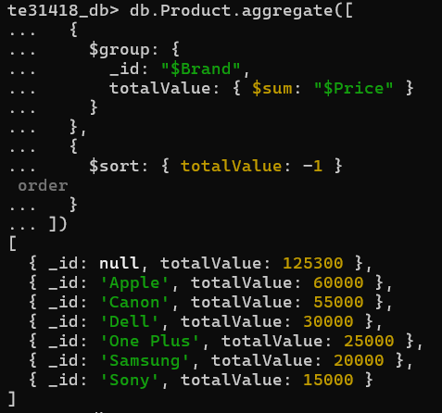

1. Sort and Limit to find top three most expensive Products:

db.Product.aggregate([

{

$sort: { Price: -1 } // Sort by price in descending order

},

{

$limit: 3 // Limit to top 3 products

}

])

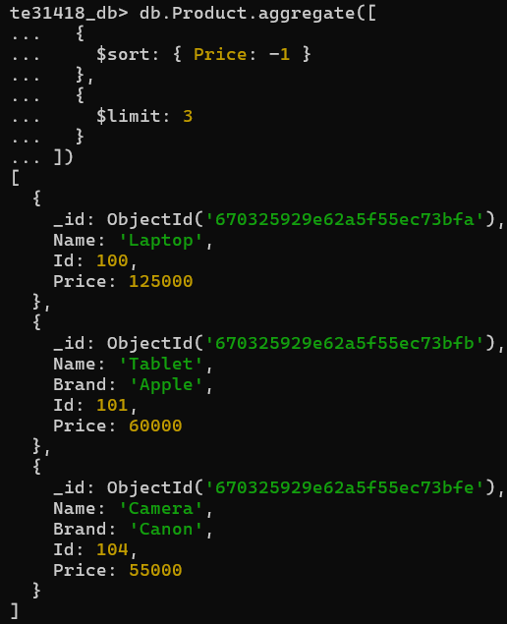

1. Using sort and match to find products worth more than 50000:  
   db.Product.aggregate([

{

$match: { Price: { $gt: 50000 } } // Filter products with price > 50,000

},

{$sort: { Price: 1 } }])

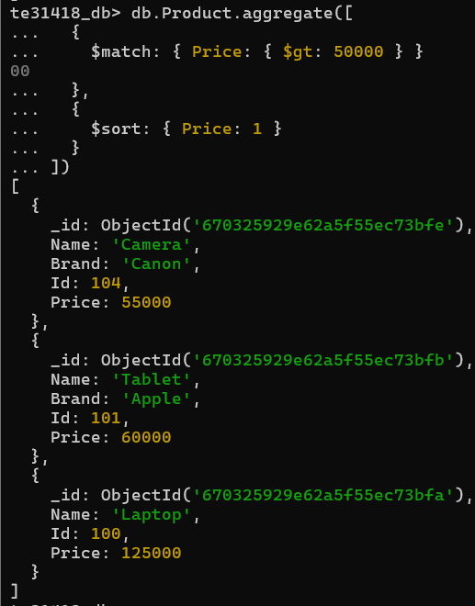

1. Find products for which Brand exists and find its avg:

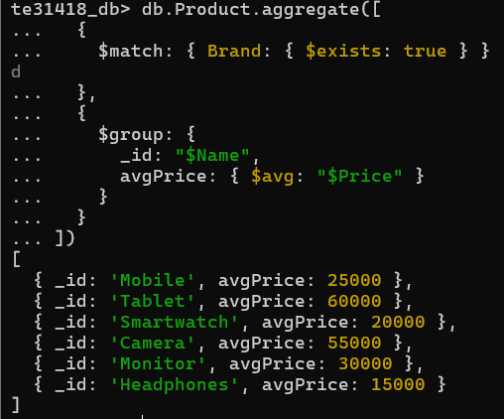

**INDEX:**

1. Create Index:

db.Product.createIndex({ Price: 1 })



1. View Indices on a Table:

db.Product.getIndexes();

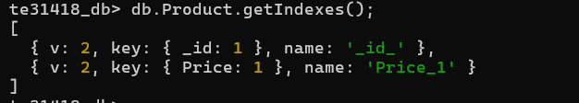

1. Drop Index:

db.Product.dropIndex('Price_1');